Save the dates!

Begin your “Financial Fitness” journey with us now!
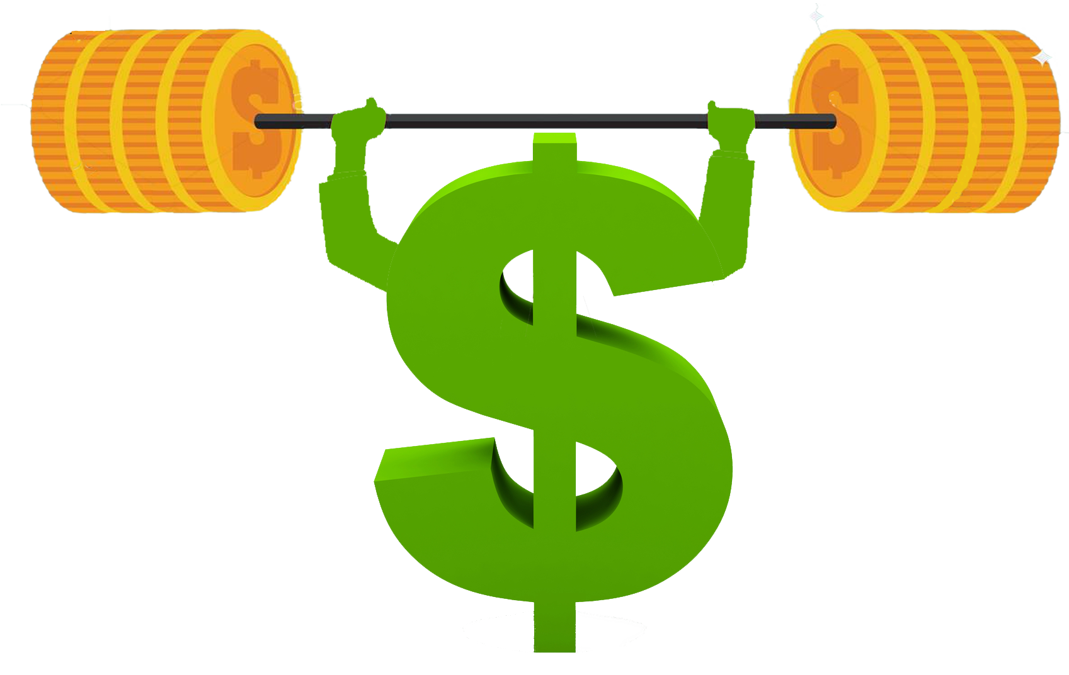

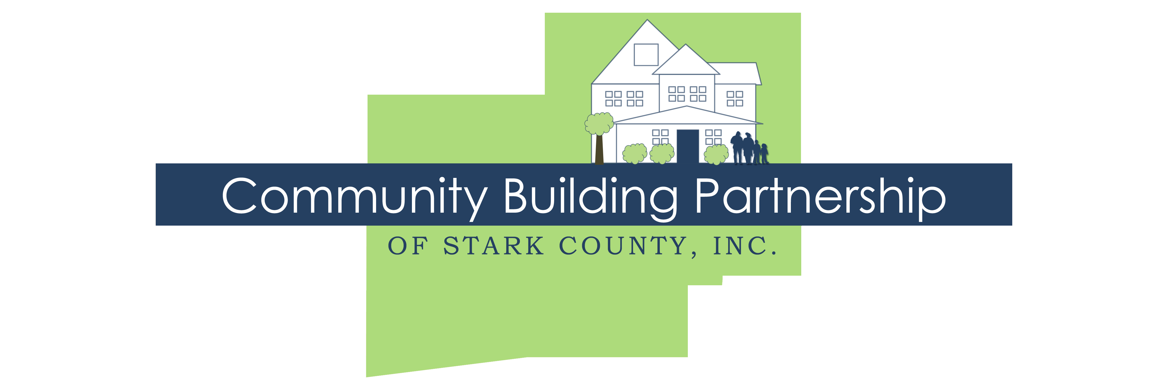

Community Building Partnership and Huntington Bank invite you to join our FREE Financial Fitness Workshop series! Every month from October through June this series offers guidance and support as you work toward your financial goals, whether improving your credit score, saving money, buying a car, or becoming a homeowner.
All workshops are held the second Tuesday of every month from 5:30-6:30 p.m.
October 11, 2022 Introduction
November 8, 2022 Money Matters: Developing Your Spending Plan
December 13, 2022 Pay Yourself First: Ways to Save Money
January 10, 2023 Understanding Credit: Charge it Right & Borrowing Basics
February 14, 2023 Consumer Rights & Protecting Yourself: Loan to Own & Keep it Safe
March 14, 2023 Bank On It: Building a Relationship with Lenders
April 11, 2023 Financial Recovery: Rebuilding Credit & Recovering After a Financial Setback
May 9, 2023 Your Own Home: Steps to Homeownership
June 13, 2023 Series Recap and Celebration of Success!
Be sure to RSVP!
www.communitybuildingpartnership.org (330)458-0962
400 Market Avenue N., Suite 400, Canton, OH 44702

